Year 10
OLNA class

Test 3.2

2018

Number- Rounding and BIDMAS


Name: ______________________ Class: ______ Time: 25 minutes (strict) Total Mark:____/17

Resources: No calculator allowed

Question 1 3 marks

Consider the number 46 541 and perform the following:
a) | Round to the nearest thousand
b) | Round to the nearest hundred
c) | Round to the nearest ten

Question 2 2 marks

Marilyn and Kim disagree about the answer to the following calculation:
5.6 + 6.2 + 5.7 + 5.8 + 5.9 + 6.3 + 6.4 + 5.6.
Marilyn says the answer is 47.5, but Kim thinks it is 40.5. Obtain and write an estimate for the calculation and determine who is correct.

Question 3 2 marks

Calculate
a) | 144 ÷ 12 + 6 × 2 – 5 | b) | 2 × (63 ÷ 9) + 3 × 2

Question 4 8 marks [4, 4]

The four planets closest to the Sun are shown with their diameter measurements.
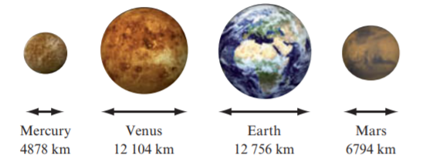
a) | Round the figures to the nearest thousand to estimate the diameter of each of the planets
b) | Draw a number line and mark these approximate values on it. Label each value with the name of the planet.

Question 5 2 marks

James and Liz discovered that they had different answers to the same question, which was to calculate 10 + 10 ÷ 5. James thought the answer was 4. Liz thought the answer was 12. Who was correct, James or Liz? Provide an explanation.

END OF TEST

